
YENEPOYA INSTITUTE OF ARTS, SCIENCE, COMMERCE AND MANAGEMENT

LOW LEVEL DESIGN (LLD)

ANOMALY DETECTION FOR FINANCIAL TRANSACTIONS USING Z-SCORE

Student Name: Salima M K
Register No: 23BSAMD027
Course: BSc Artificial Intelligence, Machine Learning and Data Science

Industry Mentor: Mr. Sumit Kumar Shukla
Guided By: Ankitha Poojary

TABLE OF CONTENTS
- Introduction
- Detailed Module Design
- Algorithm Design
- Data Structures
- Function-Level Design
- Error Handling
- Interface Design
- Performance Considerations
- References

1. INTRODUCTION

1.1 Scope of Document
This document presents the detailed low-level design of the anomaly detection system for financial transactions. It explains the internal modules, algorithms, data structures, and implementation details required for the system.

1.2 Intended Audience
- Developers
- Academic evaluators
- Project reviewers

1.3 System Overview
The system is a web-based application developed using Streamlit that detects anomalies in financial transaction data using the Z-Score statistical method. Users can upload a CSV dataset, and the system processes the data to identify abnormal transactions. The results are displayed through tables and graphical visualizations for better understanding.

2. DETAILED MODULE DESIGN

2.1 Modules

1. Input Module
- Accepts CSV file from user
- Handles file upload through Streamlit interface
- Validates file format and structure

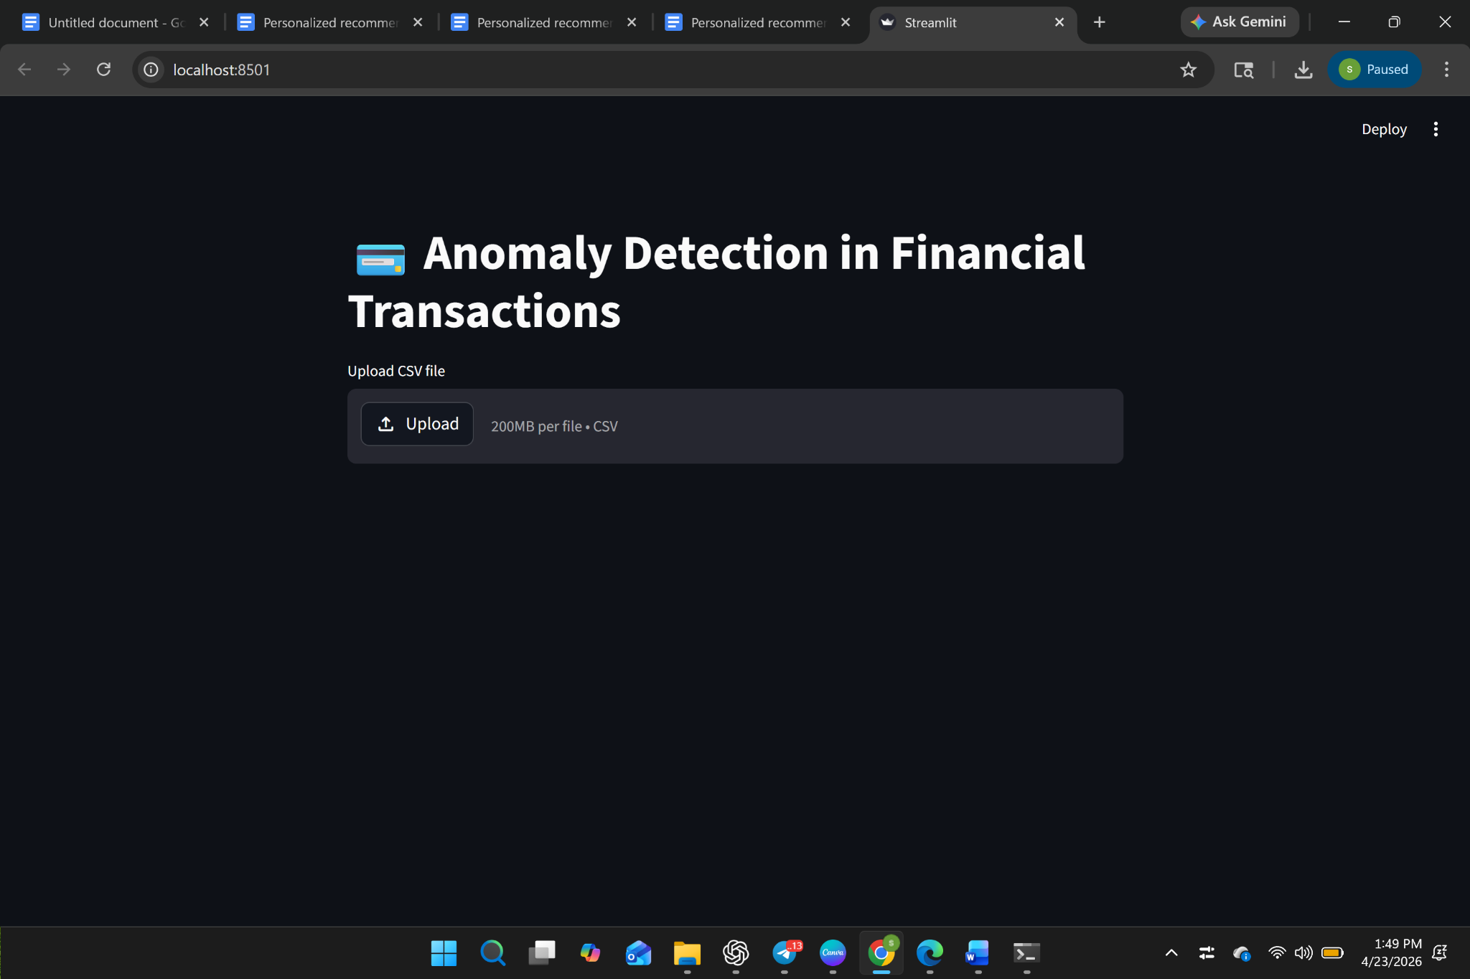

2. Data Processing Module
- Reads dataset using Pandas
- Handles missing or null values
- Converts data into numeric format
- Selects transaction amount column for analysis
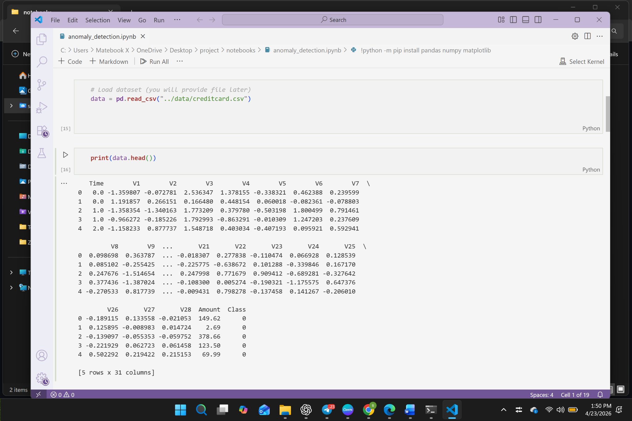

3. Anomaly Detection Module
- Calculates mean of transaction amounts
- Calculates standard deviation
- Computes Z-score for each transaction
- Identifies anomalies using condition: |Z-score| > 3
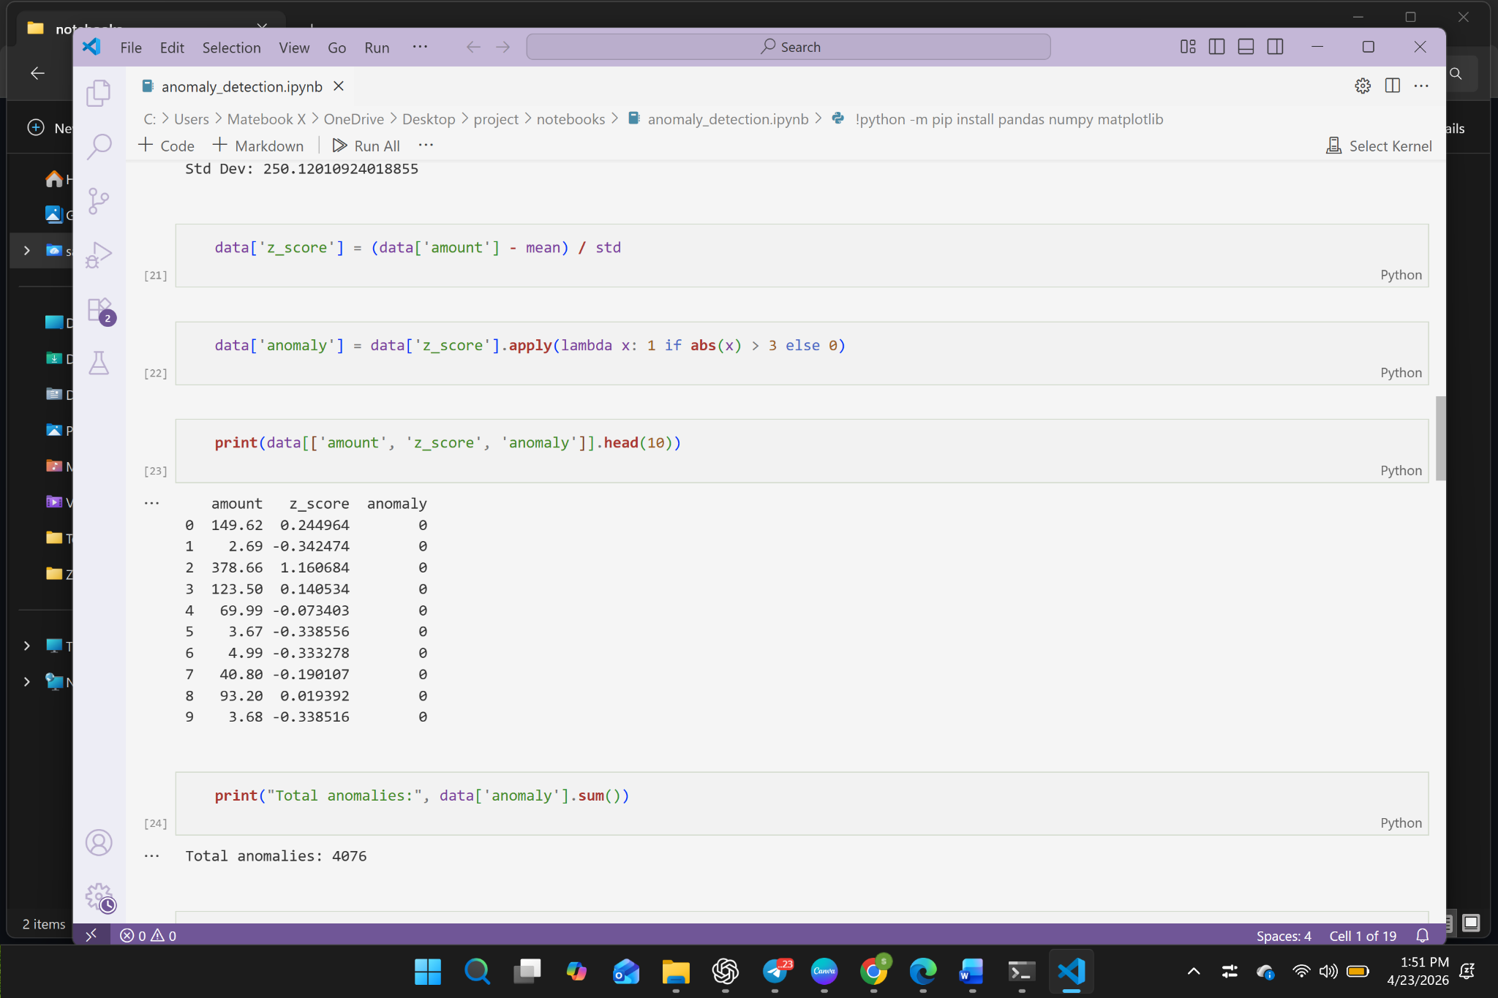

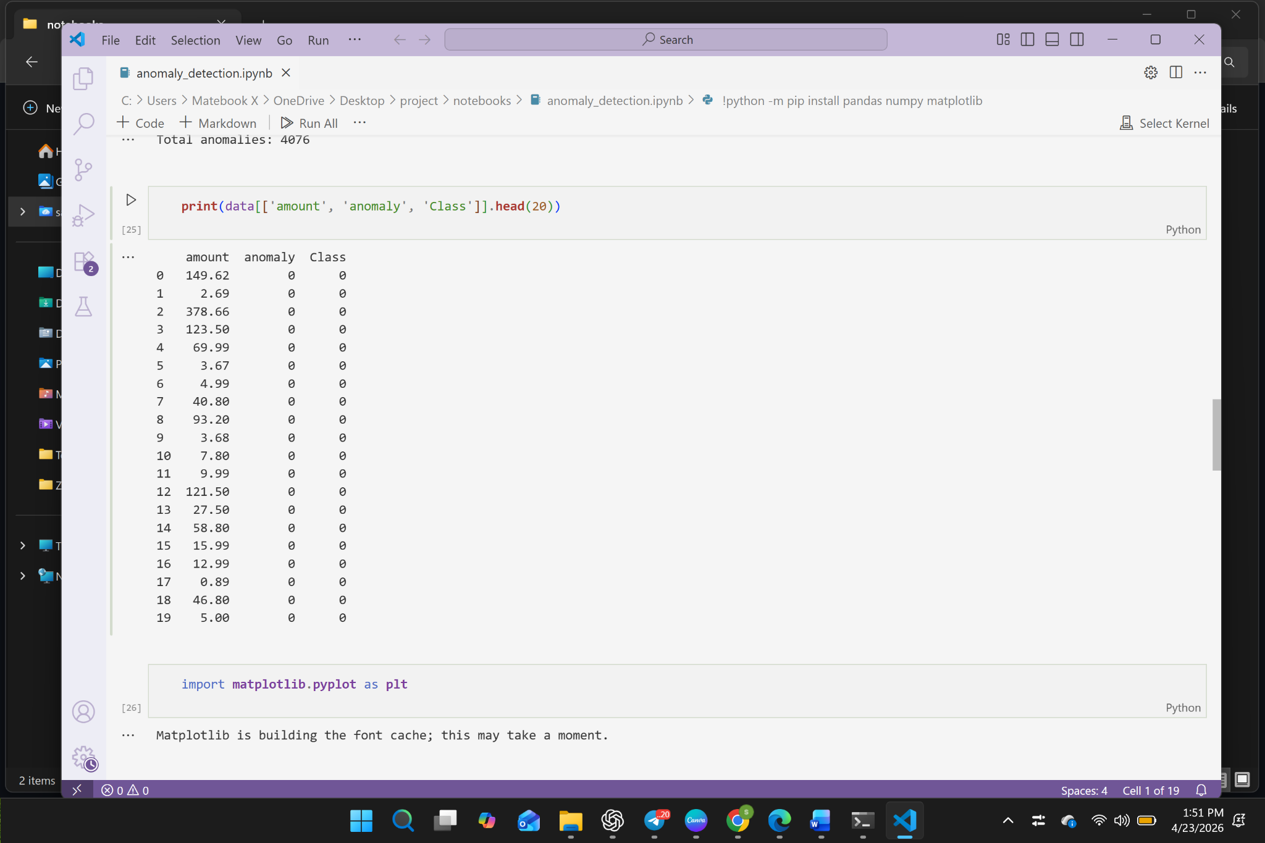

4. Visualization Module
- Generates histogram of transaction data
- Creates boxplot to identify outliers
- Displays scatter plot highlighting anomalies
- Provides visual understanding of data distribution
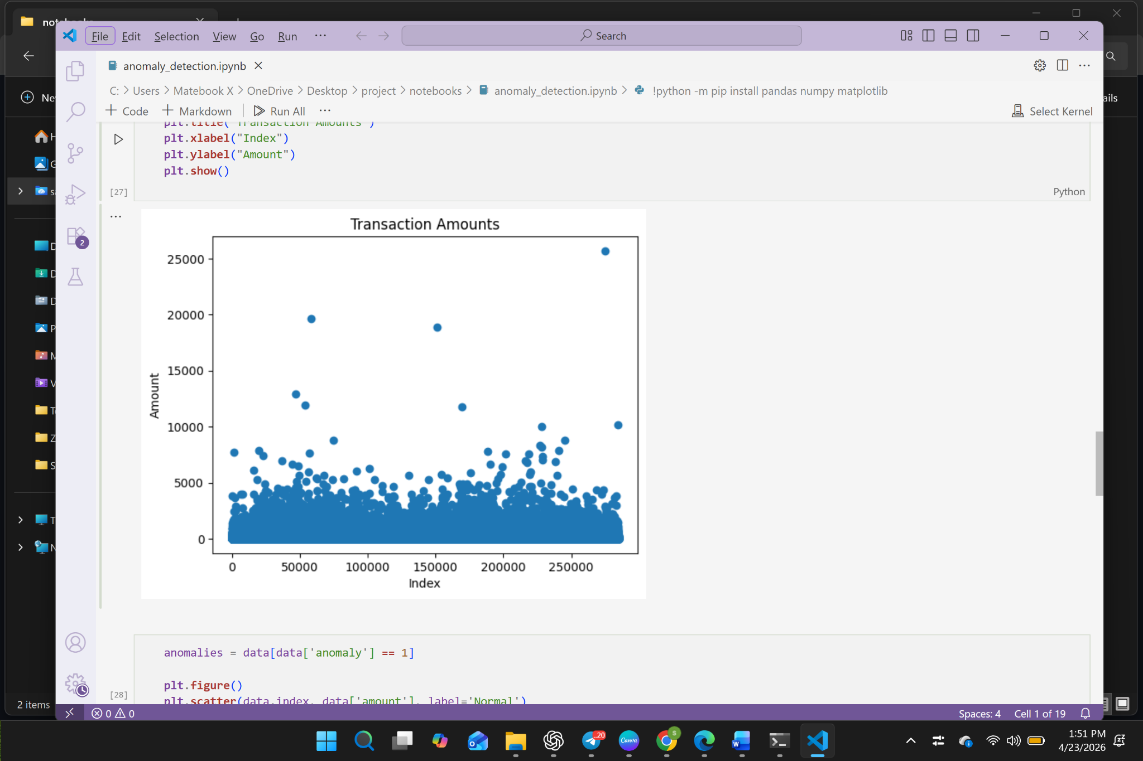

5. Output Module
- Displays processed dataset
- Highlights anomalous transactions
- Shows total number of anomalies
- Provides option to download results as CSV
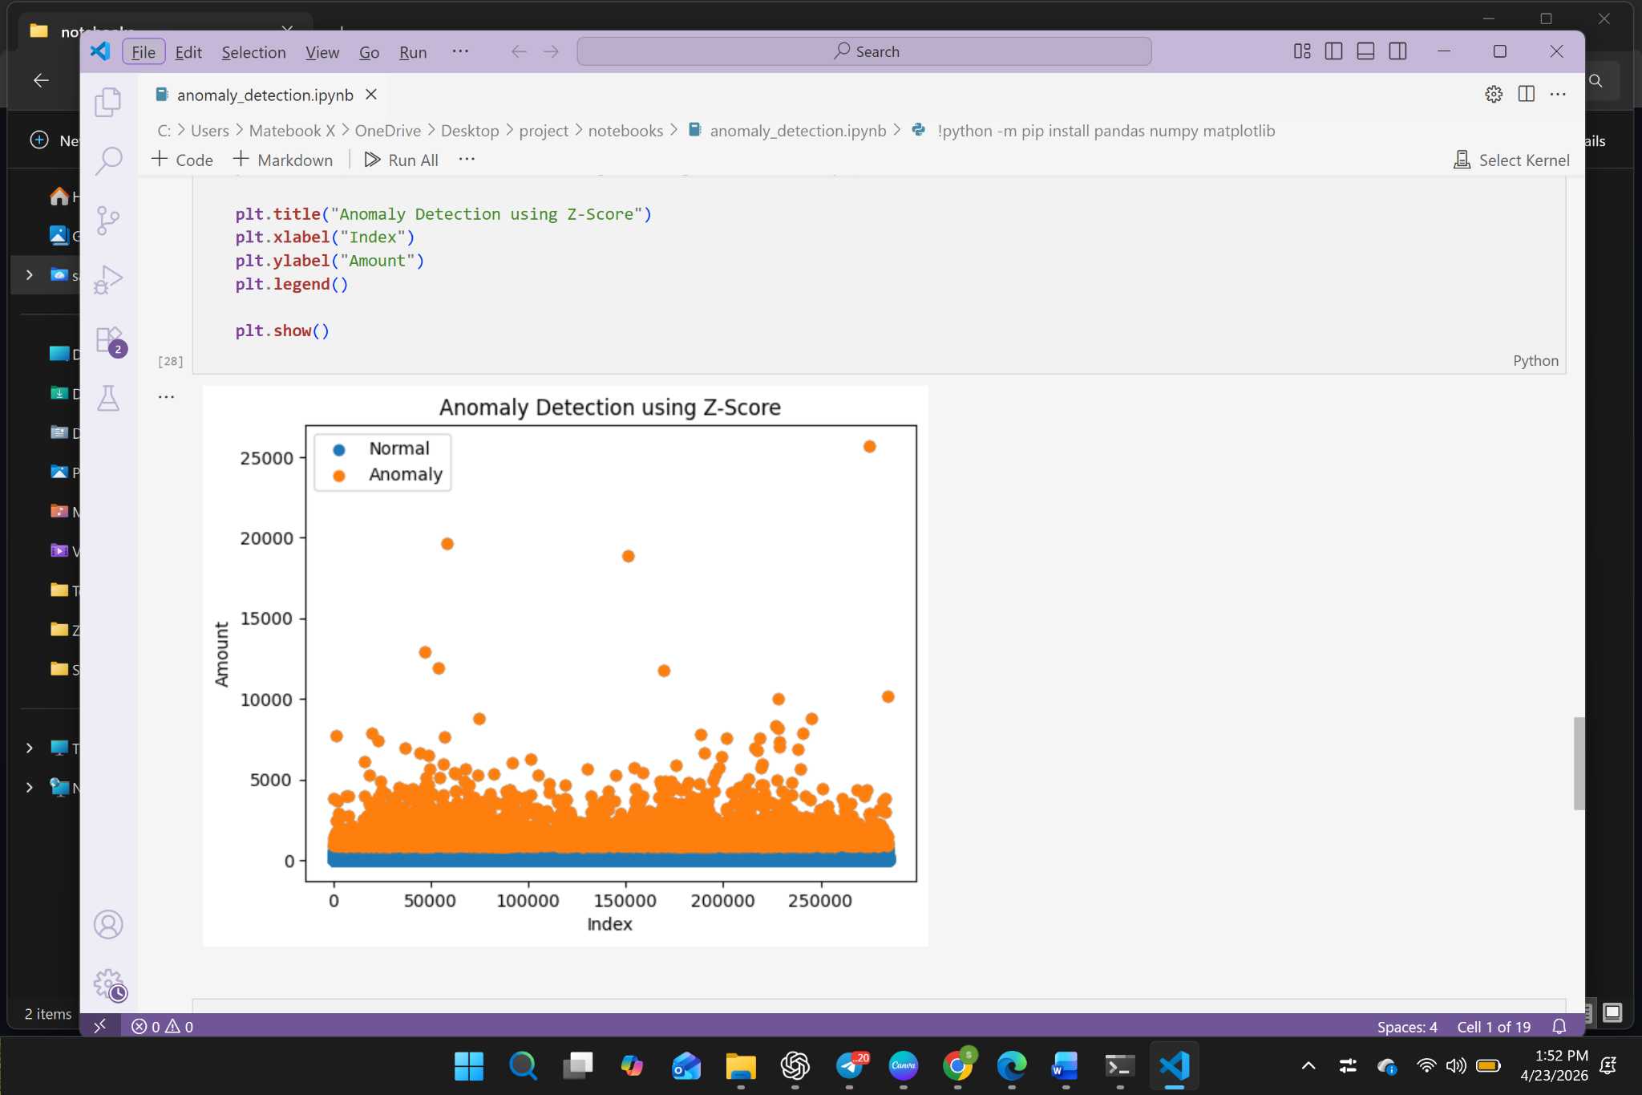

3. ALGORITHM DESIGN

3.1 Z-Score Algorithm
Steps:
- Load dataset from CSV file
- Select transaction amount column
- Calculate mean (μ)
- Calculate standard deviation (σ)
- Compute Z-score using formula:
Z = (X - μ) / σ
- If Z-score > 3 or Z-score < -3, mark as anomaly
- Store and display results

3.2 Data Preprocessing Algorithm
- Load dataset
- Check for missing values
- Remove or replace null values
- Ensure numeric data format
- Pass cleaned data to anomaly detection module

4. DATA STRUCTURES

Data Structure | Description
Dataset | Pandas DataFrame
Transaction Amount | Numeric Column
Z-Scores | Pandas Series
Anomalies | DataFrame
Threshold Value | Float

5. FUNCTION-LEVEL DESIGN

5.1 load_data(file)
- Input: CSV file
- Output: DataFrame

5.2 preprocess_data(df)
- Handles missing values
- Converts data types
- Returns cleaned dataset

5.3 calculate_zscore(df, column)
- Calculates mean and standard deviation
- Computes Z-score values
- Returns Z-score list

5.4 detect_anomalies(df, threshold)
- Identifies anomalies based on Z-score
- Adds anomaly flag column
- Returns updated dataset

5.5 visualize_data(df)
- Generates histogram, boxplot, and scatter plot
- Highlights anomalies visually

5.6 display_results(df)
- Displays dataset preview
- Shows anomaly records
- Displays summary statistics

6. ERROR HANDLING
- Invalid file format → display error message
- Missing column → prompt user
- Empty dataset → show warning
- Zero standard deviation → handle safely
- Incorrect data type → convert or notify user

7. INTERFACE DESIGN

7.1 User Interface
- Streamlit web interface
- File upload option
- Column selection dropdown
- Button to run anomaly detection

7.2 Output Interface
Displays:
- Dataset preview
- Anomaly detection results
- Graphs (histogram, boxplot, scatter plot)
- Download option

8. PERFORMANCE CONSIDERATIONS
- Efficient processing using Pandas
- Vectorized operations for faster execution
- In-memory processing for quick response
- Suitable for moderate to large datasets

9. REFERENCES
- https://pandas.pydata.org/docs/
- https://numpy.org/doc/
- https://docs.streamlit.io/
- https://matplotlib.org/stable/contents.html
- https://en.wikipedia.org/wiki/Standard_score
- https://scikit-learn.org/stable/modules/outlier_detection.html

